U1352883 Robin Yang

Web Assignment 2

A Sheltered Workshop Documentations

**Use Case Diagram**

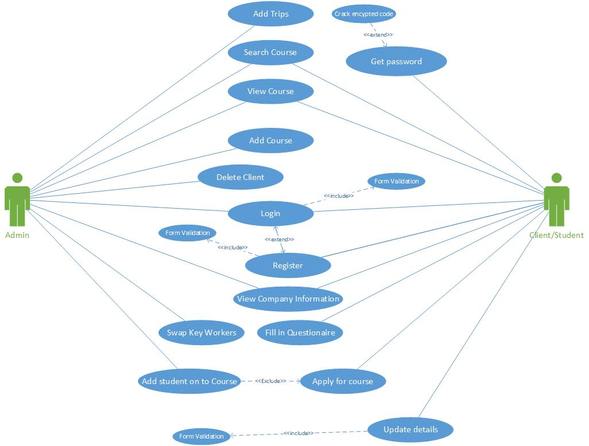

Use case diagram between the Admin (carer) and the Client. These are the potential activities which could be implemented on to the website.

**Use Cases**

|  |  |
| --- | --- |
| **Use Case Number: 1** | **Use Case Name: View Courses** |
| **Overview:** users who visits this website will be able to search for a course and view its details. They can use this facility to understand what they will be learning before making a decision to join the courses | |
| **Actors:** Admin, Users/Clients | |
| **Pre-conditions:** Load webpage first | |
| **Primary Path:**   1. Get on to webpage 2. Enter keyword into search box 3. Press enter 4. Choose result or click on result 5. View details on the course details page | |
| **Use Cases related to Primary Path:** None | |
| **Alternatives:** None | |
| **Exceptions:** Server is currently down, these details can be retrieved in the about us page but it will not be very informatively | |

|  |  |
| --- | --- |
| **Use Case Number: 2** | **Use Case Name: Login** |
| **Overview:** Users who uses the website to login to their own profile. Admins are extended with further features such as amendment | |
| **Actors:** Admin, Users/Clients | |
| **Pre-conditions:** Load webpage first | |
| **Primary Path:**   1. Get on to web page 2. Click login on the side menu bar 3. Enter username (either user or admin) 4. Enter password 5. Click login 6. View your account with options | |
| **Use Cases related to Primary Path:** Register | |
| **Alternatives:** Register yourself in the user page to create yourself an account | |
| **Exceptions:** Server is currently down and cannot retrieve user details login | |

|  |  |
| --- | --- |
| **Use Case Number: 3** | **Use Case Name: Register** |
| **Overview:** Users can creates themselves an account to get themselves onto a course or change their details. | |
| **Actors:** Users/Clients | |
| **Pre-conditions:** Load webpage first | |
| **Primary Path:**   1. Get on to webpage 2. Click register to get to registering page 3. Enter name 4. Enter surname 5. Choose sex 6. Enter username 7. Enter email 8. Enter password 9. Confirm password by entering the same password again 10. Enter telephone number 11. Click submit 12. Sign in page will be loaded | |
| **Use Cases related to Primary Path:** Login | |
| **Alternatives:** Login, if you already have own an account | |
| **Exceptions:** Server is currently down, these details cannot be added on to the database. | |

**Sequence diagram**

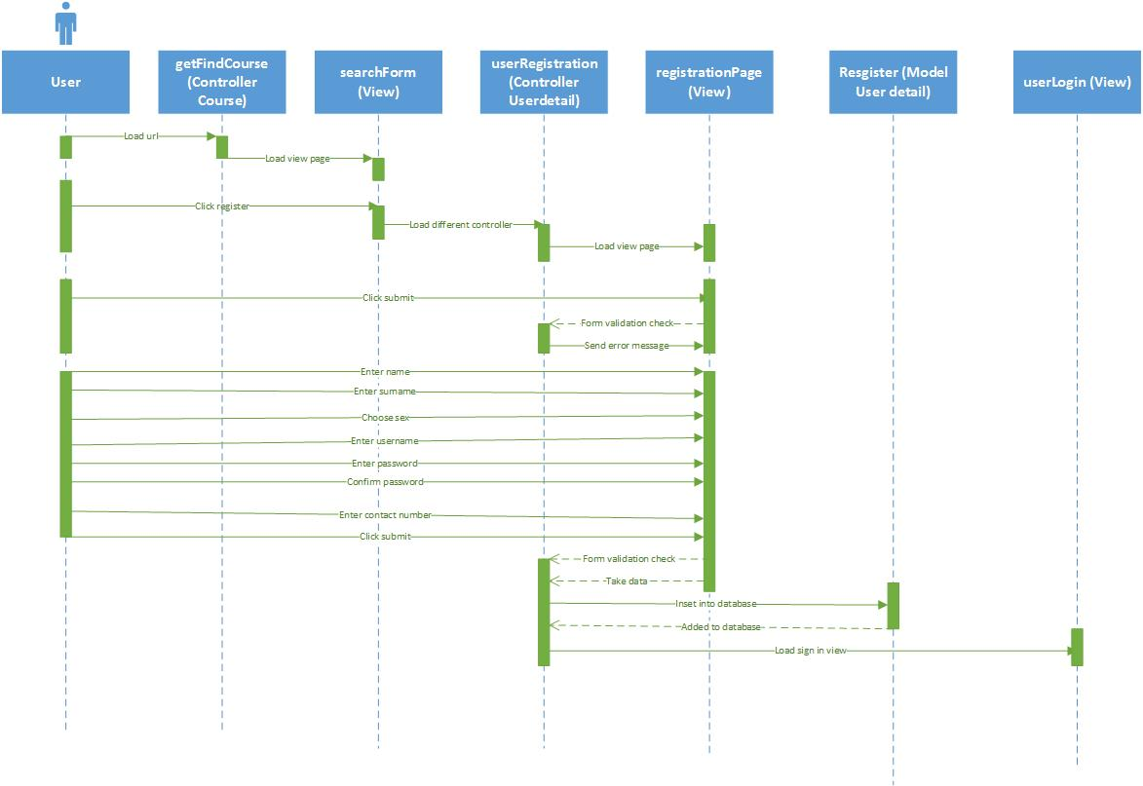**Register:**

Steps for this register sequence diagram:

* Actor type in the URL including the controller
* Then the controller will load search form view
* When the view is shown, the user will click register
* The button will activates the controller linked
* The controller will run the method linked as well the controller link, loading up the registration view
* If the actor clicks submit without entering anything into the forms, the controller will run the form validation, then output error messages back in the register page echoed by the view
* Actor enters name, surname, username, password, confirm password, contact number and choose gender
* Actor clicks submit
* The view will run the method linked to the controller, validating the inputs and taking in the data
* The controller passes the data into the model to insert into the database
* The model has successfully added them onto the database then return true to controller
* The controller will sent actor to sign in view for them to sign in to their account

**Login:**

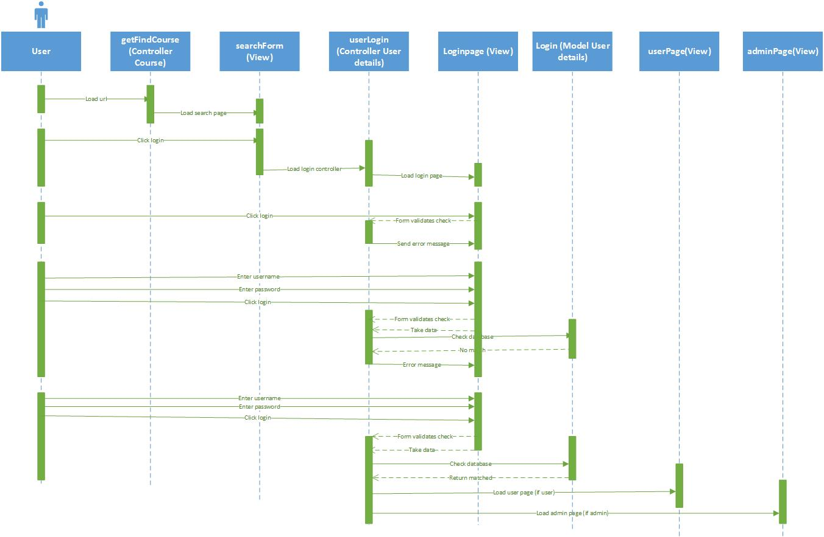

Steps for this login sequence diagram:

* Actor type in the URL including the controller
* Then the controller will load search form view
* When the view is shown, the user will click login
* The button will activates the controller linked
* The controller will run the method linked as well the controller link, loading up the login view
* If the actor clicks login without entering anything into the forms, the controller will run the form validation then outputs error messages back in the login page by the view
* If the actor enters username and password then clicks login. The controller will take input from the view, run the method linked to the controller, validating the inputs and taking in the data. The controller will pass the data into the model to check with the database. If nothing is found in the database, the model will return false. The controller will load this login page again with error messages shown by the view.
* The actor enters username and password then clicks login
* The controller will take input from the view, run the method linked to the controller, validating the inputs and taking in the data
* The controller will pass the data into the model to check with the database
* If the data matches the database, the model will return true to the controller
* The controller will load either user page or admin page depending on which the username belong to users or admin

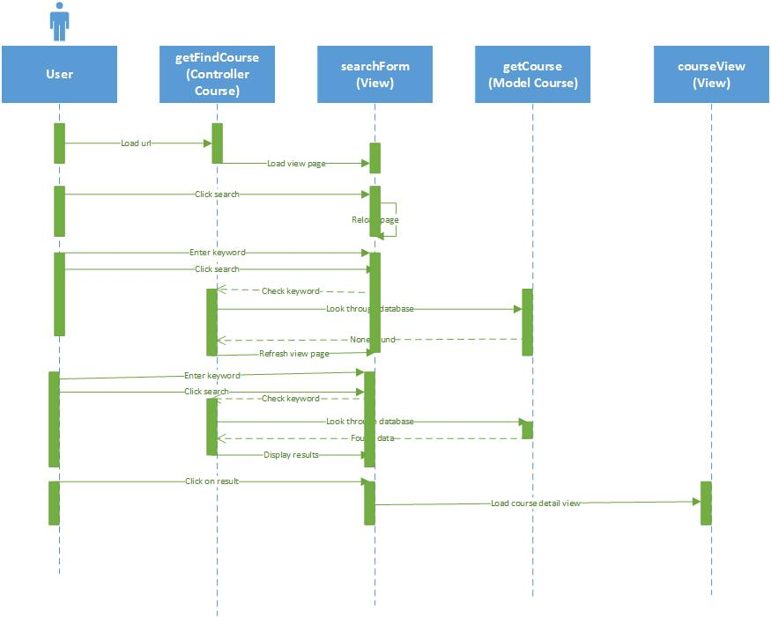**View course:**

Steps for this view course details sequence diagram:

* Actor types in the URL including the controller
* Then the controller will load search form view
* When the view is shown, the user will click search
* Because nothing was inputted, the view will reload itself
* The actor enters key work, clicks search. The input will be passed into the controller then model will be launched by the controller with these data. The model will look through the database for matching keywords. The model returns false to the controller. The controller will refresh the search form view
* The actor enters key work, clicks search
* The input will be passed into the controller then model will be launched by the controller with these data
* The model will look through the database for matching keywords
* The model returns true to the controller
* The controller will sends data to the view then the view will show results
* Actor clicks on a result
* The results will be hyperlinked and loads up the detail page for the chosen course

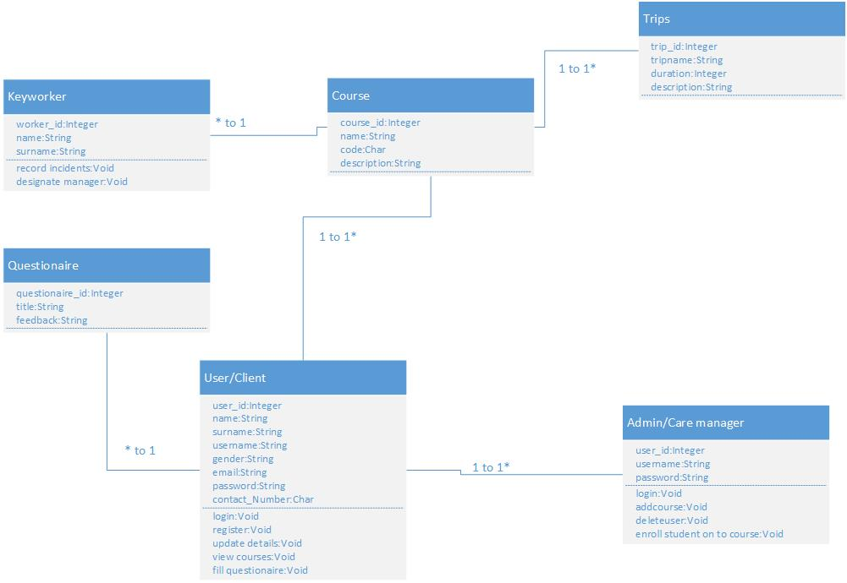**Class diagram:**

A summarise of the case study, with relationship shown.